Building chat application using JS and pusher

Prerequisites:

* You should create a free account on pusher.com to be able to complete the task
* Pusher acts as a real-time communication server
* You should use the pusher.js library in your code
* You should not use any other library (e.g., axios jQuery, etc..). Just use native JS
* You can use any CSS library (bootstrap, etc.)
* You can split you logic to 2 modules (pusher and otherlogic)

Task description:

* Create chat application that contains the 2 following screens (2 screens should be built in one html page. You should hide and show each screen according to the current state)
* Screen # 1 User stories:
  + As unlogged user I can type an existing group name and my name to access the chat window (screen #2)
  + As unlogged user I can type a new group name and my name to create a new group
* Screen #1 S/W Specifications:
  + Application should check the existing group name (even if name is written in difference letter cases, i.e., lower/upper cases)
  + Username can be duplicated in the same group, but a unique id should be assigned to each logged in user (the id should be stored in browser’s local storage)
  + Joining group is equivalent to subscribing in pusher channel
* Screen #2 User stories:
  + As logged-in user I can view number of current online users, and if any user logged in or logged out the counter should change
  + I should view new messages only (no need to view old messages sent before logging in)
  + I can logout from the 2nd screen by clicking logout button
  + I should view my messages labeled as (You) and view sender usernames at the start of each message
  + I should view my messages on the right side of the screen and view other user messages on the left side of the screen.
  + I should view message received date and time (local date and time)
  + I can send messages by clicking send message button or by pressing (Enter) key
  + I can type new line by pressing (Alt+Enter) keys
  + I should view a counter down timer (starts from 1 min) that indicates the idle time (time spent without sending messages)
  + If the counter down timer reaches 0, I should be logged out automatically
* Screen #2 S/W Specifications:
  + Logging out should by done by unsubscribing in current pusher channel and clearing the browser’s local storage.

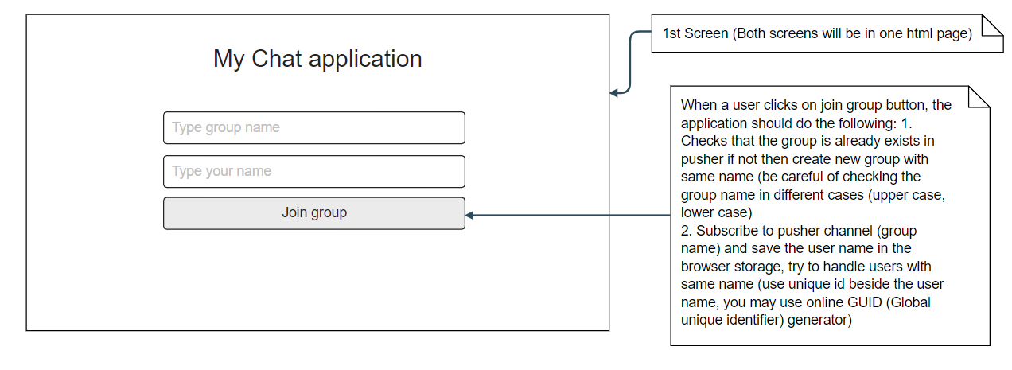

Figure 1: Screen # 1

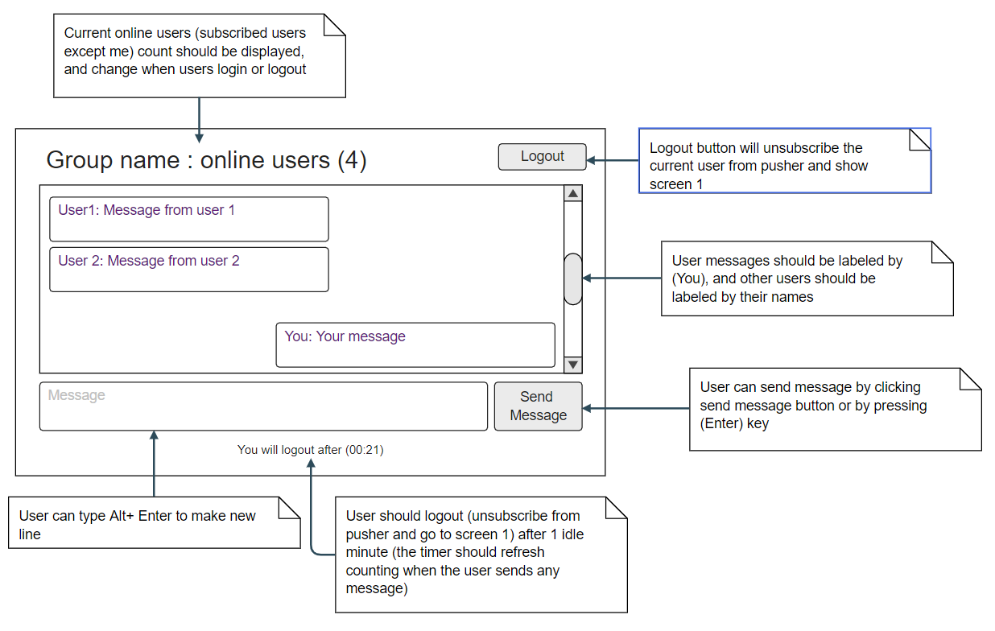

Figure 2: Screen #2

Task 1 (Deadline 29/8/2021 4PM) “Chat Application UI”:

* Create the user interface (you can create 2 screens in 2 different DIVs and show the 2 DIVs)
* Create empty functions and event listeners with console.log(‘function name’)
* Attach event listeners to events (key events and button events)
* Create pusher account and read about pusher

Task 2 (Deadline 31/8/2021 4PM) “Chat Application UI Logic ”:

* Implement screen 1 logic
* Implement all event listeners
* Implement the logout button (without pusher unsubscribe channel)
* Implement the count-down timer logic

Task 3 (Deadline 3/9/2021 4PM) “Chat Application Pusher Logic”:

* Complete Pusher final logic
* Test the application intensively